Test Case: tc001_SPX_Dev5_Crear_Requisicion_Spot_Tipo_Cobro_CC
Step 1 - Enter username and password and click to button Enter : Credentials Entered
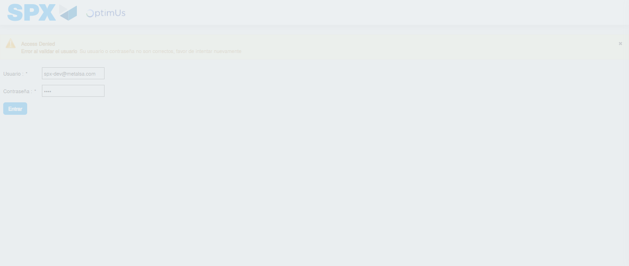Image file-name: QC_Testing-tc001_SPX_Dev5_Crear_Requisicion_Spot_Tipo_Cobro_CC-1783359044211

Step 2 - Select to UEN and Access to Spot Buy Requisitions : UEN Correctly selected and Correct access
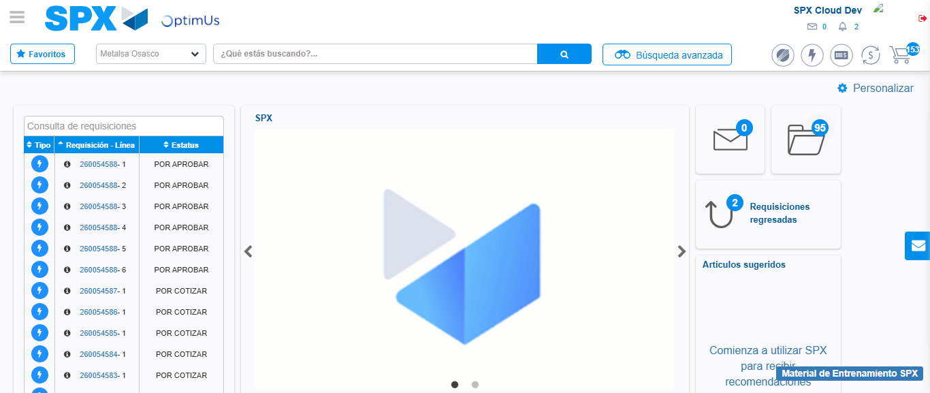Image file-name: QC_Testing-tc001_SPX_Dev5_Crear_Requisicion_Spot_Tipo_Cobro_CC-1783359070472

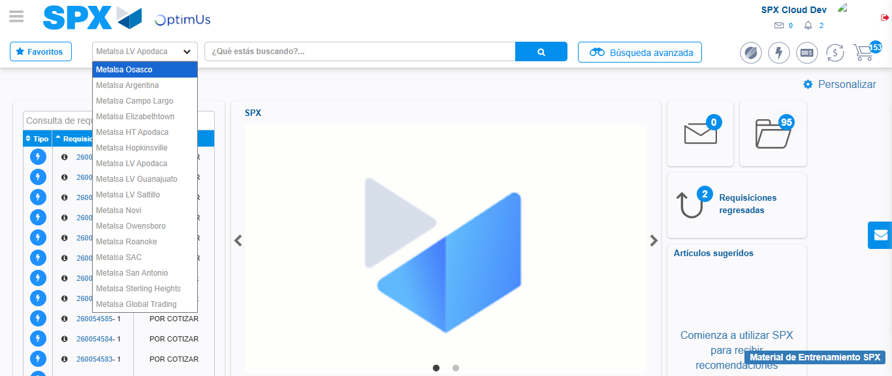Image file-name: QC_Testing-tc001_SPX_Dev5_Crear_Requisicion_Spot_Tipo_Cobro_CC-1783359073548

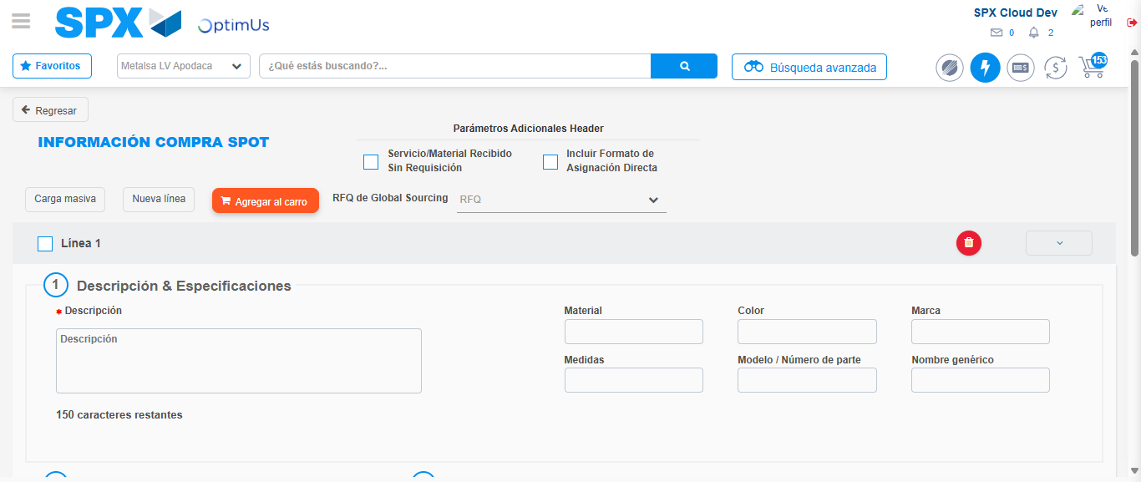Image file-name: QC_Testing-tc001_SPX_Dev5_Crear_Requisicion_Spot_Tipo_Cobro_CC-1783359096020

Step 3 - Data Capture Spot Buy Requisition : Data captured correctly
Image file-name: QC_Testing-tc001_SPX_Dev5_Crear_Requisicion_Spot_Tipo_Cobro_CC-1783359096325

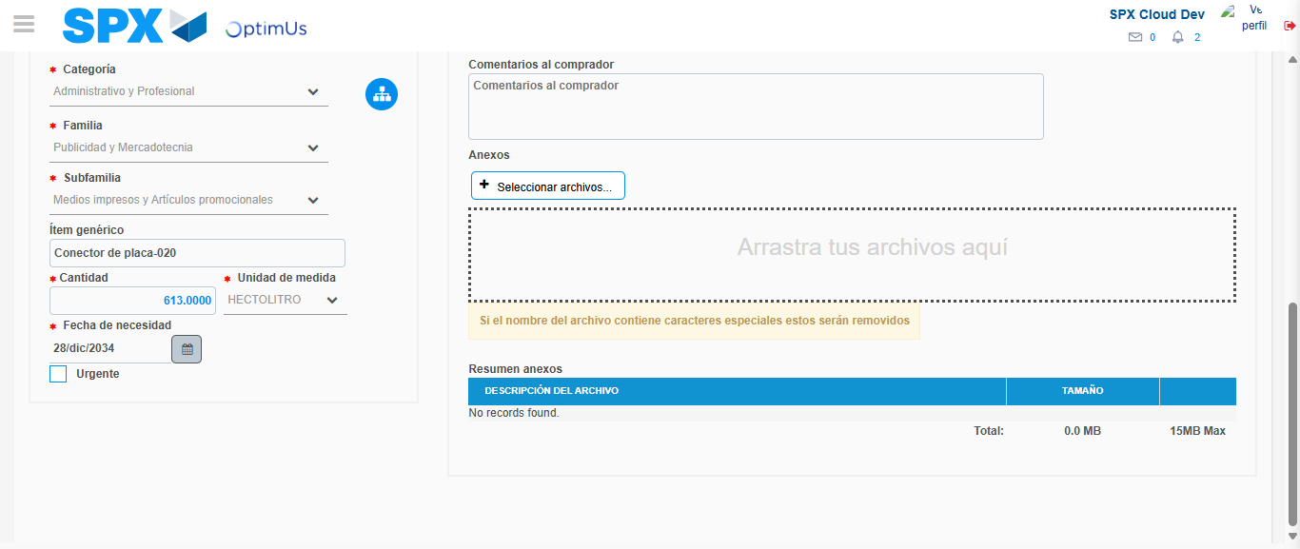Image file-name: QC_Testing-tc001_SPX_Dev5_Crear_Requisicion_Spot_Tipo_Cobro_CC-1783359109335

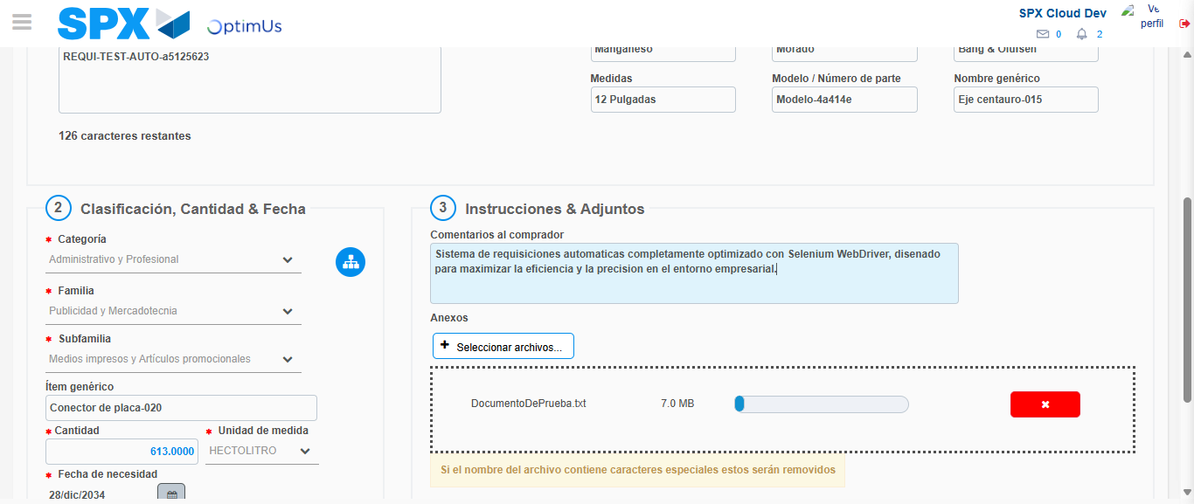Image file-name: QC_Testing-tc001_SPX_Dev5_Crear_Requisicion_Spot_Tipo_Cobro_CC-1783359110304

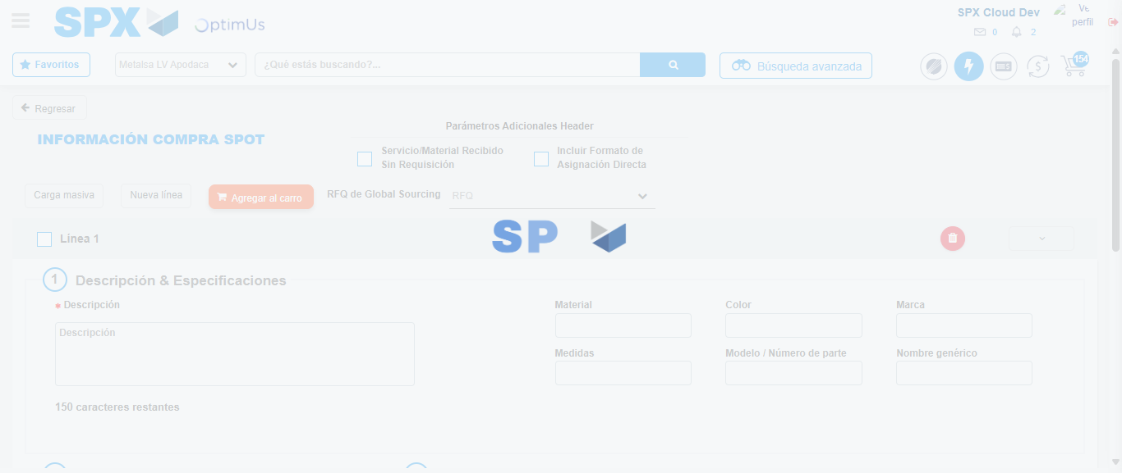Image file-name: QC_Testing-tc001_SPX_Dev5_Crear_Requisicion_Spot_Tipo_Cobro_CC-1783359113988

Step 7 - Return to Main Page SPX : Return to Main Page SPX
Image file-name: QC_Testing-tc001_SPX_Dev5_Crear_Requisicion_Spot_Tipo_Cobro_CC-1783359070472

Image file-name: QC_Testing-tc001_SPX_Dev5_Crear_Requisicion_Spot_Tipo_Cobro_CC-1783359073548

Image file-name: QC_Testing-tc001_SPX_Dev5_Crear_Requisicion_Spot_Tipo_Cobro_CC-1783359096020

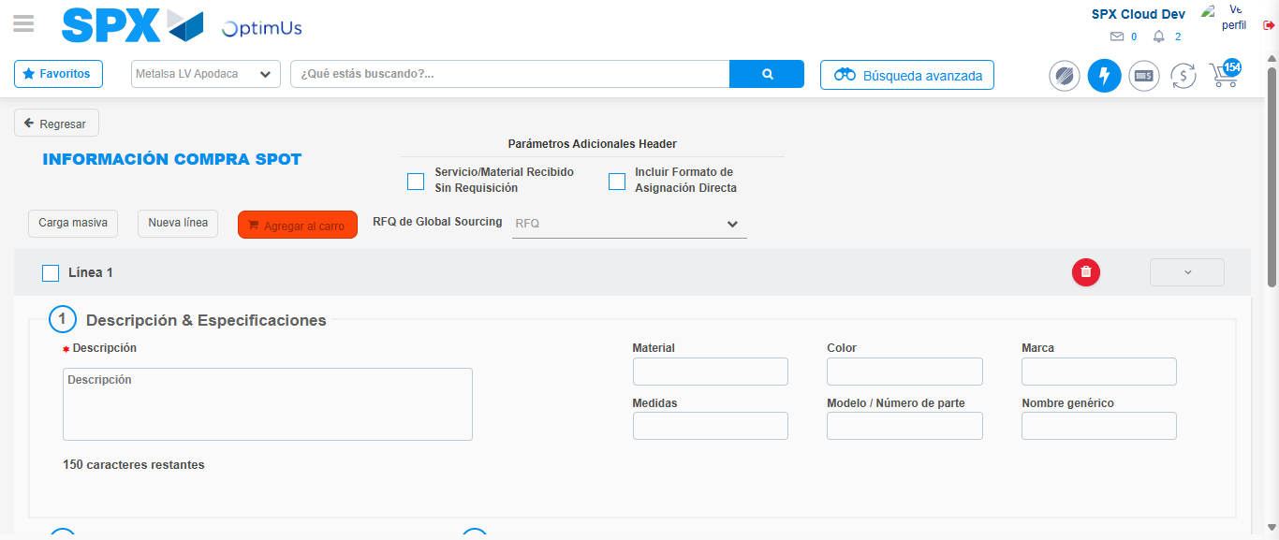Image file-name: QC_Testing-tc001_SPX_Dev5_Crear_Requisicion_Spot_Tipo_Cobro_CC-1783359116269

Image file-name: QC_Testing-tc001_SPX_Dev5_Crear_Requisicion_Spot_Tipo_Cobro_CC-1783359116482

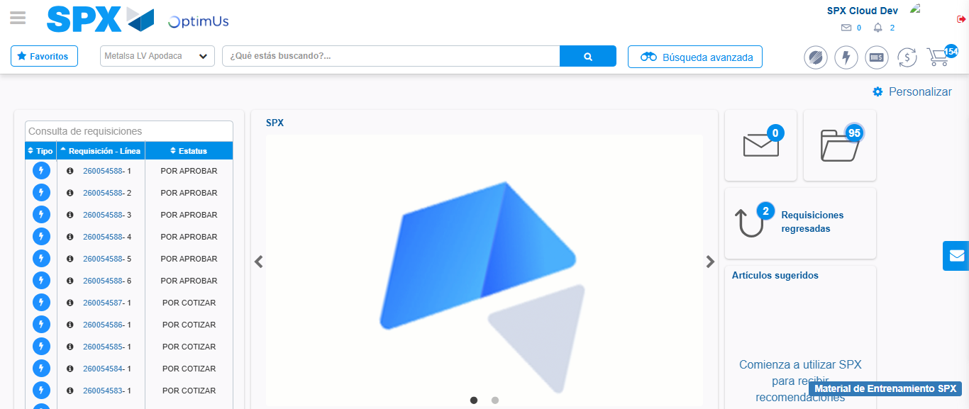Image file-name: QC_Testing-tc001_SPX_Dev5_Crear_Requisicion_Spot_Tipo_Cobro_CC-1783359138066

Step 8 - Log Out : Log Out SPX
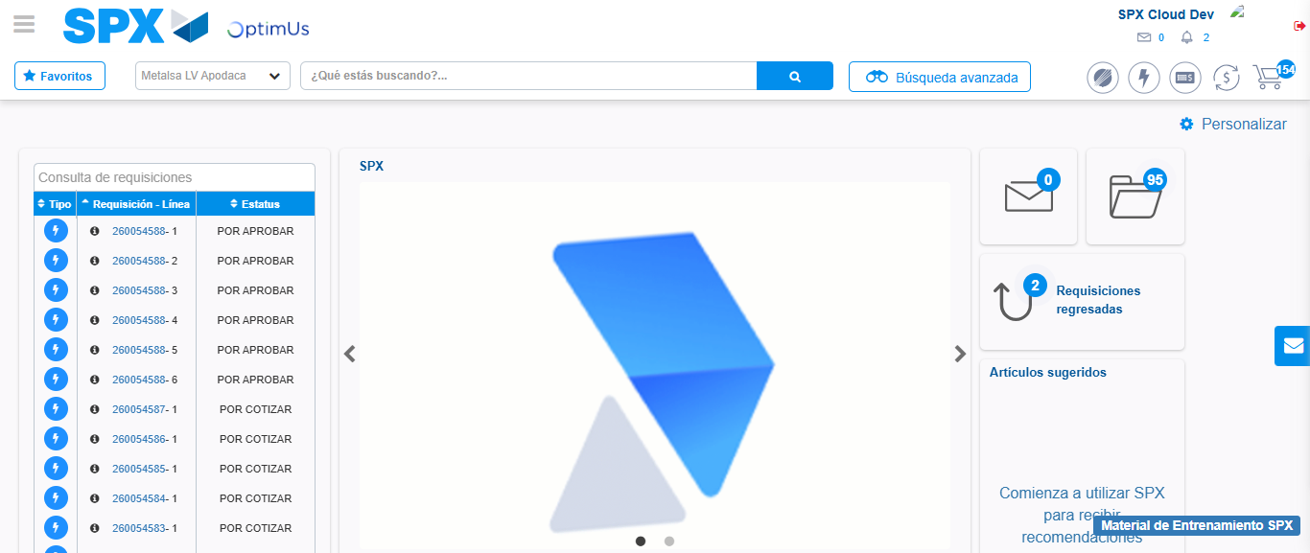Image file-name: QC_Testing-tc001_SPX_Dev5_Crear_Requisicion_Spot_Tipo_Cobro_CC-1783359138492

